
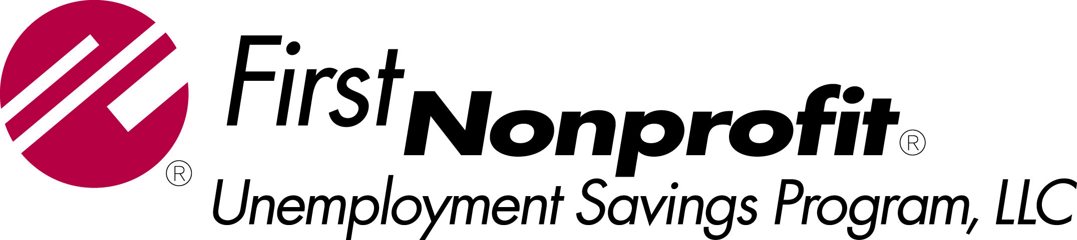

Paperless Billing Option Sign-Up Form
Paperless Billing is a service that allows you to receive your invoice via email rather than in a printed, paper format. As a paperless billing member, you opt not to receive a paper bill in the mail and will instead receive an email with your invoice attached in PDF format. This is an optional service for your convenience.

A hard copy invoice will continue to be mailed to your agency if do not choose this option.

To enroll, complete and sign the authorization form below. Please return via email to dbrouwer@firstnonprofit.com or fax it to Dawn Brouwer’s attention at 312-648-0325

Invoices can be sent to multiple email addresses.

Organization Name and Member ID:
Invoices will be sent to the following email addresses:
Contact Name #1:
Email Address #1:

Contact Name #2:
Email Address #2:

 I agree to paperless billing as described above.
Signature:
Name and Title: _____________________________________________ Date: _____________

